ANNAMALAI  UNIVERSITY

FACULTY OF ENGINEERING AND TECHNOLOGY

DEPARTMENT OF COMPUTER SCIENCE AND ENGINEERING

B.E. COMPUTER SCIENCE AND ENGINEERING

(ARTIFICIAL INTELLIGENCE AND MACHINE LEARNING)
V – SEMESTER

22AICP510 - NEURAL COMPUTING LAB

Name: Reg No:

ANNAMALAI UNIVERSITY

FACULTY OF ENGINEERING AND TECHNOLOGY

DEPARTMENT OF COMPUTER SCIENCE AND ENGINEERING

B.E. COMPUTER SCIENCE AND ENGINEERING

(ARTIFICIAL INTELLIGENCE AND MACHINE LEARNING)
V – SEMESTER

22AICP510 - NEURAL COMPUTING LAB

Certified that this is the Bonafide Record of work done by Mr./Ms Reg. No. of V semester B.E. Computer Science and Engineering (Artificial Intelligence and Machine Learning) in the 22AICP510 - Neural Computing Laboratory during the odd semester (June2025 – Nov2025).

Staff Incharge

External Examiner Internal Examiner

Place: Annamalai Nagar
Date: / / 2025
DEPARTMENT OF COMPUTER SCIENCE AND ENGINEERING

VISION

To provide a congenial ambience for individuals to develop and blossom as academically superior, socially conscious and nationally responsible citizens.
MISSION

M1: Impart high quality computer knowledge to the students through a dynamic scholastic environment wherein they learn to develop technical, communication and leadership skills to bloom as a versatile professional.

M2: Develop life-long learning ability that allows them to be adaptive and responsive to the changes in career, society, technology, and environment

M3: Build student community with high ethical standards to undertake innovative research and development in thrust areas of national and international needs.

M4: Expose the students to the emerging technological advancements for meeting the demands of the industry.

PROGRAMME EDUCATIONAL OBJECTIVES (PEO)

PEO | PEO STATEMENTS
PEO1 | To equip the graduates with fundamental concepts and impart problem solving skills that will help them to pursue professional careers in Computer Science and Engineering.
PEO2 | To provide the graduates with the requisite knowledge to pursue higher education and carry out research in the field of Computer Science and Engineering.
PEO3 | To equip the graduates with the ability to acquire new skills in emerging areas of Computer Science and Engineering such as artificial intelligence, machine learning and data science and enable them to become successful professionals and entrepreneurs.
PEO4 | To ensure that the graduates exhibit high levels of ethical and moral behavior as computer engineers in addressing societal problems and providing sustainable development for the betterment of society.

PROGRAMME SPECIFIC OUTCOMES
PSO1: Acquire the ability to understand basic sciences, humanity sciences, basic engineering sciences and fundamental core courses in Machine Learning, Deep Learning and Artificial Intelligence in terms of real world problems to meet the challenges of the future.
PSO2: Learn specialized courses in Machine Learning, Deep Learning and Artificial Intelligence to develop intelligent systems for solving problems from inter-disciplinary domains and for applying typical practices and approaches to deliver quality products intended for business and industry requirements.
PSO3: Apply innovative tools and techniques to solve problems in the areas related to Machine learning, Deep Learning, and Artificial Intelligence essential for employing current techniques to model real world problems in software development and to create pioneering career paths for pursuing higher studies, research and to be an entrepreneur.
COURSE OBJECTIVES
- To provide the most comprehensive concept of neural networks in the engineering perspective
- To understand the important design concepts of neural architectures in different applications
- To acquaint student with various computing algorithms in FLNN using software tools.
- To understand operation of basic elements in fuzzy logic and neural network through simulation.

LIST OF EXERCISES

- Write a program to implement the concept of Perceptron.
- Write a program to simulate Back-Propagation Neural Networks.
- Write a program to implement the Radial Basis Function Neural Networks.
- Write a program to implement a real-world application using Support Vector Machine.
- Write a program to implement a Self-Organizing Map and a Learning Vector Quantization for an application.
- Write a program to implement fuzzy set operations.
- Write a program to implement fuzzy set properties.
- Write a program to implement fuzzy membership functions.
- Write a program to develop a fuzzy inference system.
- Write a program to implement defuzzification methods using fuzzy toolbox.
- Write a program to develop an application using Fuzzy logic.

COURSE OUTCOMES

At the end of this course, the students will be able to
  - Demonstrate basic concepts fuzzy logic and neural network through simulation.
  - Develop the logic given in problem statement using operations in fuzzy logic and basics of toolbox studied.
  - Demonstrate an ability to listen and answer viva questions related to programming skills for solving real world problems in Computer Science and Engineering.

MAPPING OF COURSE OUTCOMES WITH PROGRAMME OUTCOMES

 | PO1 | PO2 | PO3 | PO4 | PO5 | PO6 | PO7 | PO8 | PO9 | PO10 | PO11 | PO12
CO1 | 2 | 3 | 3 | 3 | 2 | - | - | - | - | - | - | -
CO2 | 2 | 3 | 2 | 2 | 2 | - | - | - | - | - | - | -
CO3 | 2 | 2 | - | - | - | - | - | - | - | - | - | 2

Rubric for CO3 in Laboratory Courses
Rubric | Distribution of 10 Marks for CIE/SEE Evaluation Out of 40/60 Marks
Rubric | Up To 2.5 Marks | Up To 5 Marks | Up To 7.5 Marks | Up To 10 marks
Demonstrate | Poor listening and | Showed better | Demonstrated good | Demonstrated
an ability to | communication | communication | communication skills | excellent
listen and | skills. Failed to | skill by relating the | by relating the | communication
answer the | relate the | problem with the | problem with the | skills by relating the
viva questions | programming skills | programming skills | programming skills | problem with the
related to | needed for solving | acquired but the | acquired with few | programming skills
programming | the problem. | description | errors. | acquired and have
skills needed |  | showed serious |  | been successful in
for solving |  | errors. |  | tailoring the
real-world |  |  |  | description.
problems in
Computer
Science and
Engineering.

Table of Contents

S. No. | Date | Title | Page | Mark | Signature
1. |  | - Perceptron Algorithm on Randomly Generated Dataset  - Perceptron Algorithm for OR Gate | 1
2. |  | - Back Propagation Neural Network  - BPNN for OR Gate | 7
3. |  | - Radial Basis Function Neural Network  - RBFNN for XOR Gate | 15
4. |  | - Support Vector Machine on Ads Dataset  - Support Vector Machine for XOR Gate | 23
5. |  | - Self-Organizing Maps  - Learning Vector Quantization | 29
6. |  | Fuzzy Set Operations | 34
7. |  | Fuzzy Set Properties | 36
8. |  | Fuzzy Membership Functions | 41
9. |  | Fuzzy Inference System | 43
10. |  | Defuzzification Methods | 48
11. |  | Fuzzy Controller System | 51

Ex. No. 1(a) Perceptron Algorithm on Randomly Generated Dataset

Date:

Aim:
To implement perceptron algorithm using Python programming.

Perceptron Learning:
The Perceptron algorithm is a two-class (binary) classification machine learning algorithm. It is the simplest type of neural network model. It consists of a single node or neuron that takes a row of data as input and predicts a class label. This is achieved by calculating the weighted sum of the inputs and a bias (set to 1). The weighted sum of the input of the model is called the activation given as
Activation = Weights * Inputs + Bias
If the activation is above 0.0, the model will output 1.0; otherwise, it will output 0.0 given as:

Predict 1: If Activation > 0.0
Predict 0: If Activation <= 0.0
The Perceptron is a linear classification algorithm. This means that it learns a decision boundary that separates two classes using a line (called a hyperplane) in the feature space. The coefficients of the model are referred to as input weights and are trained using the stochastic gradient descent optimization algorithm.

Examples from the training dataset are shown to the model one at a time, the model makes a prediction, and error is calculated. The weights of the model are then updated to reduce the errors for the example. This is called the Perceptron update rule. This process is repeated for all examples in the training dataset, called an epoch. This process of updating the model using examples is then repeated for many epochs.

Model weights are updated with a small proportion of the error each batch, and the proportion is controlled by a hyperparameter called the learning rate, typically set to a small value as shown below.
weights(t + 1) = weights(t) + learning_rate * (expected_i – predicted_) * input_i Training is stopped when the error made by the model falls to a low level or no longer
improves, or a maximum number of epochs is performed. The initial values for the model
weights are set to small random values.

Algorithm:
- Set a threshold value
- Multiply all inputs with their weights
- Sum all the results
- Activate the output and return true if greater than the threshold.

Program:
import numpy as np
from sklearn import datasets import matplotlib.pyplot as plt
X, y = datasets.make_blobs(n_samples=150,n_features=2, centers=2,cluster_std=1.05, random_state=2)
#Plotting
fig = plt.figure(figsize=(10,8))
plt.plot(X[:, 0][y == 0], X[:, 1][y == 0], 'r^')
plt.plot(X[:, 0][y == 1], X[:, 1][y == 1], 'bs')
plt.xlabel("feature 1")
plt.ylabel("feature 2")
plt.title('Random Classification Data with 2 classes')

def step_func(z):
return 1.0 if (z > 0) else 0.0

def perceptron(X, y, lr, epochs): # X --> Inputs.
# y --> labels/target. # lr --> learning rate.
# epochs --> Number of iterations. # m-> number of training examples # n-> number of features
m, n = X.shape
# Initializing parameters(theta) to zeros. # +1 in n+1 for the bias term.
theta = np.zeros((n+1,1))
# Empty list to store how many examples were # misclassified at every iteration.

n_miss_list = []

# Training.
for epoch in range(epochs):
# variable to store #misclassified. n_miss = 0
# looping for every example. for idx, x_i in enumerate(X):
# Insering 1 for bias, X0 = 1.
x_i = np.insert(x_i, 0, 1).reshape(-1,1) # Calculating prediction/hypothesis. y_hat = step_func(np.dot(x_i.T, theta))
# Updating if the example is misclassified. if (np.squeeze(y_hat) - y[idx]) != 0:
theta += lr*((y[idx] - y_hat)*x_i) # Incrementing by 1.
n_miss += 1
# Appending number of misclassified examples # at every iteration. n_miss_list.append(n_miss)
return theta, n_miss_list

def plot_decision_boundary(X, theta): # X --> Inputs
# theta --> parameters # The Line is y=mx+c
# So, Equate mx+c = theta0.X0 + theta1.X1 + theta2.X2 # Solving we find m and c
x1 = [min(X[:,0]), max(X[:,0])]
m = -theta[1]/theta[2] c = -theta[0]/theta[2] x2 = m*x1 + c
# Plotting
fig = plt.figure(figsize=(10,8)) plt.plot(X[:, 0][y==0], X[:, 1][y==0], "r^")

plt.plot(X[:, 0][y==1], X[:, 1][y==1], "bs")
plt.xlabel("feature 1")
plt.ylabel("feature 2") plt.title('Perceptron Algorithm') plt.plot(x1, x2, 'y-')
theta, miss_l = perceptron(X, y, 0.5, 100) plot_decision_boundary(X, theta)

Input and Output:

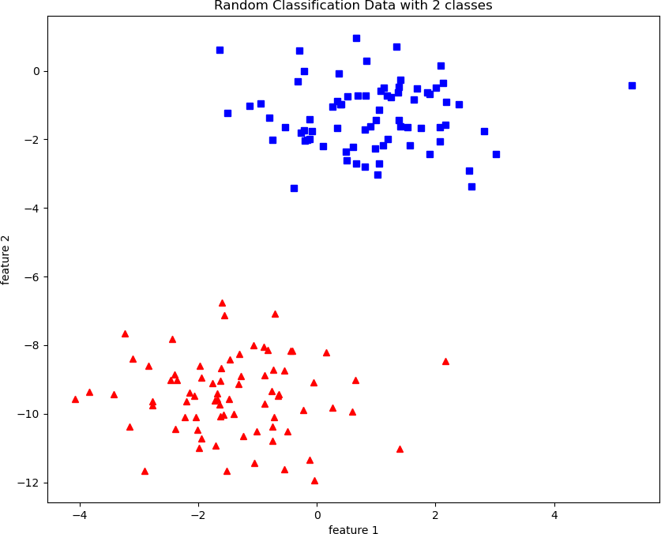

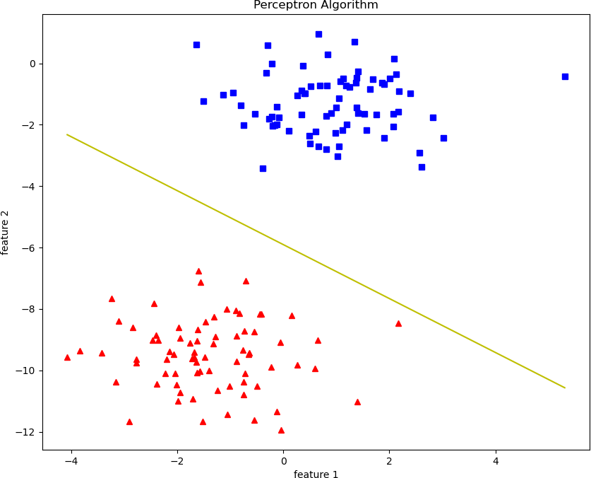

Result:
Thus a python program has been written and executed to implement perceptron algorithm.

Ex. No. 1(b) Implementation of OR Gate using Perceptron Algorithm

Date:
Aim:
To implement OR gate using perceptron algorithm in Python programming.

Program:
import numpy as np class Perceptron:
def init (self) -> None: self.weights = np.zeros((2, 1)) self.bias = 0

def predict(self, x: np.array) -> np.array:
return np.where(np.dot(x, self.weights) + self.bias > 0, 1, 0)

def fit(self, x: np.array, y: np.array, epoch:int = 100, learning_rate: float= 0.1) -> None: for _ in range(epoch):
for x_i, y_i in zip(x, y):
y_hat = self.predict(x_i).squeeze()
self.weights += learning_rate * (y_i - y_hat) * x_i.reshape(-1, 1) self.bias += learning_rate * (y_i - y_hat)

def score(self, x: np.array, y: np.array) -> float: y_hat = self.predict(x).squeeze()
return np.mean(y_hat == y)

if name == ' main ':
X = np.array([[0, 0], [0, 1], [1, 0], [1, 1]])
y = np.array([0, 1, 1, 1])

perceptron = Perceptron() print("OR Gate: ")
for x, y_i in zip(X, y): print(x, y_i)
print("Initial Weights:")

print(perceptron.weights, perceptron.bias)

perceptron.fit(X, y, epoch=3)

print("Trained Weights:") print(perceptron.weights, perceptron.bias)

print("OR Gate(predicted): ") for x in X:
print(x, perceptron.predict(x)) print("Accuracy:", perceptron.score(X, y))

Input and Output:
OR Gate:
[0 0] 0
[0 1] 1
[1 0] 1
[1 1] 1
Initial Weights:
[[0.]
[0.]] 0
Trained Weights:
[[0.1]
[0.1]] 0.0
OR Gate(predicted):
[0 0] [0]
[0 1] [1]
[1 0] [1]
[1 1] [1]

Accuracy: 1.0

Result:
Thus the python program to implement OR gate with perceptron algorithm is successfully executed and the output is verified.

Ex. No. 2 (a) BACKP ROPAGATION NEURAL NETWORK
Date:

Aim:
To implement Back Propagation Neural Network using Python programming.

Algorithm:
The Back propagation algorithm in neural network computes the gradient of the loss function for a single weight by the chain rule. It efficiently computes one layer at a

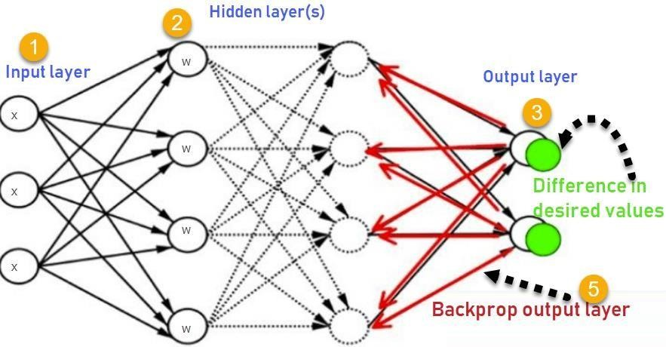
time, unlike a native direct computation
Consider the following Back propagation Neural Network.
- Inputs X, arrive through the preconnected path.
- Input is modeled using real weights W. The weights are usually randomly selected.
- Calculate the output for every neuron from the input layer, to the hidden layers, to the output layer.
- Calculate the error in the outputs
Error= Actual Output – Desired Output

- Travel back from the output layer to the hidden layer to adjust the weights such that the error is decreased.
Keep repeating the process until the desired output is achieved.

Program:
import numpy as np
# X = (hours sleeping, hours studying), y = score on test X = np.array(([2, 9], [1, 5], [3, 6]), dtype=float)
y = np.array(([92], [86], [89]), dtype=float) print(X)
print(y)
# scale units
X = X/np.amax(X, axis=0) # maximum of X array y = y/100 # max test score is 100
print(X) print(y)
class Neural_Network(object): def init (self):
#parameters self.inputSize = 2
self.outputSize = 1
self.hiddenSize = 3 #weights
self.W1 = np.random.randn(self.inputSize, self.hiddenSize) # (3x2) weight matrix from input to hidden layer
self.W2 = np.random.randn(self.hiddenSize, self.outputSize) # (3x1) weight matrix from hidden to output layer

def forward(self, X):
#forward propagation through our network
self.z = np.dot(X, self.W1) # dot product of X (input) and first set of 3x2 weights self.z2 = self.sigmoid(self.z) # activation function

self.z3 = np.dot(self.z2, self.W2) # dot product of hidden layer (z2) and second set of 3x1 weights
o = self.sigmoid(self.z3) # final activation function return o

def sigmoid(self, s):
# activation function return 1/(1+np.exp(-s))

def sigmoidPrime(self, s): #derivative of sigmoid return s * (1 - s)

def backward(self, X, y, o):
# backward propgate through the network self.o_error = y - o # error in output
self.o_delta = self.o_error*self.sigmoidPrime(o) # applying derivative of sigmoid to error
self.z2_error = self.o_delta.dot(self.W2.T) # z2 error: how much our hidden layer weights contributed to output error
self.z2_delta = self.z2_error*self.sigmoidPrime(self.z2) # applying derivative of sigmoid to z2 error
self.W1 += X.T.dot(self.z2_delta) # adjusting first set (input --> hidden) weights self.W2 += self.z2.T.dot(self.o_delta) # adjusting second set (hidden --> output) weights

def train(self, X, y):
o = self.forward(X) self.backward(X, y, o)

NN = Neural_Network()
for i in range(1000): # trains the NN 1,000 times print ("Input: \n" + str(X))
print ("Actual Output: \n" + str(y))
print ("Predicted Output: \n" + str(NN.forward(X)))
print ("Loss: \n" + str(np.mean(np.square(y - NN.forward(X))))) # mean sum squared loss print ("\n")
NN.train(X, y)

Input and Output: Input Data in First epoch:
[[ 0.66666667 1. ]
[ 0.33333333 0.55555556]
[ 1. 0.66666667]]

Actual Output:
[[ 0.92]
[ 0.86]
[ 0.89]]

Predicted Output:
[[ 0.64293334]
[ 0.64778178]
[ 0.63319242]]

Loss:
0.0625842148581

Input in second epoch:

[[ 0.66666667 1. ]
[ 0.33333333 0.55555556]
[ 1. 0.66666667]]

Actual Output:
[[ 0.92]
[ 0.86]
[ 0.89]]

Predicted Output:
[[ 0.66685628]
[ 0.67120326]
[ 0.65596939]]

Loss:
0.0514987603276
………
……….
……………

Input after 1000 epochs
[[ 0.66666667 1. ]
[ 0.33333333 0.55555556]
[ 1. 0.66666667]]

Actual Output:
[[ 0.92]
[ 0.86]
[ 0.89]]

Predicted Output after 1000 epochs
[[ 0.90015511]
[ 0.8766163 ]
[ 0.89265864]]

Loss:
0.000225663124995

Result:
Thus a python program has been written and executed to implement Backpropagation Neural Network model.

Ex. No. 2(b) BACK PROPAGATION NEURAL NETWORK
FOR OR GATE
Date:

Aim:
To implement Back Propagation Neural Network for OR gate using Python
programming.

Program:
import numpy as np
X = np.array (([0,0],[0,1],[1,0],[1,1]),dtype=float)
Y = np.array (([0],[1],[1],[1]),dtype=float) print('value X->',X)
print('value Y->',y) print('xrow,xcolm->',X.shape) print('yrow,ycolm->',y.shape)

class NeuralNetwork(object): def init (self):
self.inputsize=2 self.outputsize=1 self.hidden=2

self.w1 = np.array([[0.6, -0.3], [-0.1, 0.4]]) # Input to hidden layer self.b1 = np.array([[0.3, 0.5]]) # Bias for hidden layer (1x2)
self.w2 = np.array([[0.4], [0.1]]) # Hidden to output layer (2x1) self.b2 = np.array([[-0.2]]) # Bias for output layer (1x1) self.lr=np.array([[0.25]])

def forward(self,X): self.z=np.dot(X,self.w1) +self.b1 print('value of Z ->\n',self.z) print(' ')
self.z2=self.sigmoid(self.z) print('value of z2 -> \n',self.z2) print(' ')
self.z3=np.dot(self.z2,self.w2) +self.b2 print('value of z3 ->\n',self.z3)
print(' ')
o=self.sigmoid(self.z3) print('value of O\n',o)
print("-----FORWARD OVER ")
print(' \n\n')
return o

def sigmoid(self,s): return 1/(1+np.exp(-s))

def sigmoidprime(self,s): return s*(1-s)

def backward(self,X,y,o):
self.o_error=y-o #ERROR CALCULATION print('value of o_error->\n',self.o_error)
print(' ')

self.o_delta=self.o_error*self.sigmoidprime(o) #ERROR X DERIVATIVE print('value of o_delta->\n',self.o_delta)
print(' ')

self.z2_error=self.o_delta.dot(self.w2.T) # print('value of z2_error->\n',self.z2_error) print(' ')

self.z2_delta=self.z2_error*self.sigmoidprime(self.z2) print('value of z2_delta->\n',self.z2_delta)
print(' ')

self.w1+=X.T.dot(self.z2_delta) * 0.25 print('Value for w1 after updation->\n',self.w1) print(' ')

self.w2+=self.z2.T.dot(self.o_delta)*0.25 print('Value for w2 after updation->\n',self.w2) print(' ')
def train(self,X,y): o=self.forward(X) self.backward(X,y,o)
nn=NeuralNetwork()

nn.train(X,y)

print("input:\n"+str(X)) print(' ')
print("Actual output:"+str(y)) print(' ')
print("loss:\n"+str(np.mean(np.square(y-nn.forward(X))))) print(' ')
print("\n")

Input and Output:
value X-> [[0. 0.]
[0. 1.]
[1. 0.]
[1. 1.]]
value Y-> [[0.]
[1.]
[1.]
[1.]]
xrow,xcolm-> (4, 2)
yrow,ycolm-> (4, 1)

value of Z -> [[0.3 0.5]
[0.2 0.9]
[0.9 0.2]
[0.8 0.6]]

value of z2 -> [[0.57444252 0.62245933]
[0.549834 0.7109495 ]
[0.7109495 0.549834 ]
[0.68997448 0.64565631]]

value of z3 -> [[0.09202294]
[0.09102855]
[0.1393632 ]
[0.14055542]]

value of O [[0.52298951]
[0.52274144]
[0.53478452]
[0.53508112]]

-----FORWARD OVER
0.2280669610416859

Result:
Thus a python program has been written and executed to implement Backpropagation Neural Network model for an OR gate.

Ex. No. 3 (a) RADIAL BASIS FUNCTION NEURAL NETWORK
Date:

Aim:
To implement Radial Basis Function Neural Network using Python Programming.

Radial Basis Function Neural Network (RBFNN):
A Radial Basis Function Network is a particular type of neural network. In this article, An RBFNN performs classification by measuring the input’s similarity to examples from the training set. Each RBFNN neuron stores a “prototype”, which is just one of the examples from the training set. When we want to classify a new input, each neuron computes the Euclidean distance between the input and its prototype. If the input more closely resembles the class A prototypes than the class B prototypes, it is classified as class A.

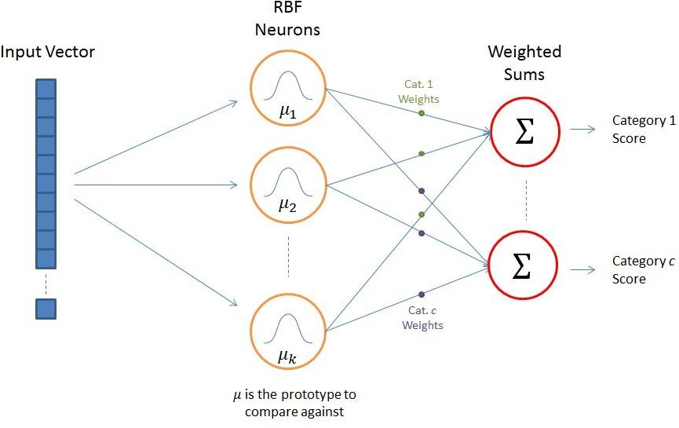

RBFNN Architecture:
The above figure shows the typical architecture of an RBF Network. It consists of an input vector, a layer of RBF neurons, and an output layer with one node per category or class of data.

The Input Vector
The input vector is the n-dimensional vector that you are trying to classify. The entire input vector is shown to each of the RBF neurons.

The RBF Neurons
Each RBF neuron stores a “prototype” vector which is just one of the vectors from the training set. Each RBF neuron compares the input vector to its prototype, and outputs a value between 0 and 1 which is a measure of similarity. If the input is equal to the prototype, then the output of that RBF neuron will be 1. As the distance between the input and prototype grows, the response falls off exponentially towards 0. The shape of the RBF neuron’s response is a bell curve, as illustrated in the network architecture diagram.The neuron’s response value is also called its “activation” value. The prototype vector is also often called the neuron’s “center”, since it’s the value at the center of the bell curve.

The Output Nodes
The output of the network consists of a set of nodes, one per category that we are trying to classify. Each output node computes a sort of score for the associated category. Typically, a classification decision is made by assigning the input to the category with the highest score.
The score is computed by taking a weighted sum of the activation values from every RBF neuron. By weighted sum we mean that an output node associates a weight value with each of the RBF neurons, and multiplies the neuron’s activation by this weight before adding it to the total response.
Because each output node is computing the score for a different category, every output node has its own set of weights. The output node will typically give a positive weight to the RBF neurons that belong to its category, and a negative weight to the others.

RBF Neuron Activation Function

Each RBF neuron computes a measure of the similarity between the input and its prototype vector (taken from the training set). Input vectors which are more similar to the prototype return a result closer to 1. There are different possible choices of similarity functions, but the most popular is based on the Gaussian. Below is the equation for a Gaussian with a one-dimensional input.

f(x) =
1

e σ√2π
−(x - μ)2
2σ2

Where x is the input, mu is the mean, and sigma is the standard deviation. This produces the familiar bell curve shown below, which is centered at the mean, mu (in the below plot the mean is 5 and sigma is 1). The RBF neuron activation function is slightly different, and is typically written as:
φ(x) = 𝑒−𝛽||𝑥−𝜇||2

In the Gaussian distribution, 𝜇 refers to the mean of the distribution. Here, it is the prototype vector which is at the center of the bell curve.

Program:
import numpy as np
import matplotlib.pyplot as plt
from sklearn.cluster import KMeans
from sklearn.datasets import make_classification from sklearn.model_selection import train_test_split from sklearn.metrics import accuracy_score
from scipy.spatial.distance import cdist
from sklearn.linear_model import LogisticRegression
X, y = make_classification(n_samples=1000, n_features=2, n_classes=2, n_clusters_per_class=2, random_state=42, n_redundant=0)
print("X and y\n")
print(X[:5], y[:5], sep="\n\n")
X_train, X_test, y_train, y_test = train_test_split(X, y, test_size=0.2) num_neurons = 10
kmeans = KMeans(n_clusters=num_neurons, random_state=42, n_init=10) kmeans.fit(X_train)
centers = kmeans.cluster_centers_ print("Center:", centers)
std_dev = np.mean(cdist(centers, centers, 'euclidean')) / np.sqrt(2*num_neurons) print("Standard Deviation:", std_dev)

def rbf_activation(X, centers, std_dev):
return np.exp(-cdist(X, centers, 'sqeuclidean') / (2 * std_dev**2)) rbf_train = rbf_activation(X_train, centers, std_dev)
rbf_test = rbf_activation(X_test, centers, std_dev)
rbf_train = np.hstack([rbf_train, np.ones((rbf_train.shape[0], 1))])

rbf_test = np.hstack([rbf_test, np.ones((rbf_test.shape[0], 1))]) clf = LogisticRegression()
clf.fit(rbf_train, y_train) y_pred = clf.predict(rbf_test)
accuracy = accuracy_score(y_pred, y_test) print("Model Accuracy: ", accuracy*100) # Visualization
def plot_result(X, y, centers=None): plt.scatter(X[y==0, 0], X[y==0, 1], label="0")
plt.scatter(X[y==1, 0], X[y==1, 1], label="1") if centers is not None:
plt.plot(centers[:, 0], centers[: ,1],'rx', label="centers") plt.legend(loc="upper right")
rbf_x = rbf_activation(X, centers=centers, std_dev=std_dev) activated_x = np.hstack([rbf_x, np.ones((rbf_x.shape[0], 1))]) plt.figure(figsize=(12, 6))
plt.subplot(121) plt.title("Original") plot_result(X, y) plt.subplot(122) plt.title("Predicted")
plot_result(X, clf.predict(activated_x), centers=centers)

Input and Output:
X and y

[[-0.99910178 -0.66386 ]
[ 1.24668618 1.15359685]
[ 0.96277683 0.85939747]
[-2.95744095 2.03364529]

[ 1.14116527 1.05944863]]

[1 1 1 1 1]
Center:
[[-0.8692364 -0.65864468]
[ 2.53446783 2.35687357]
[ 1.98458412 -1.101229 ]
[-2.16151064 2.60967372]
[-0.13595674 0.47263506]
[-1.41909706 -2.21144242]
[-1.89697275 0.99213769]
[ 1.23312034 1.21393961]
[ 0.61193541 -1.041979 ]
[-0.16678152 2.0800995 ]]
Standard Deviation: 0.6120404511235887
Model Accuracy: 85.0

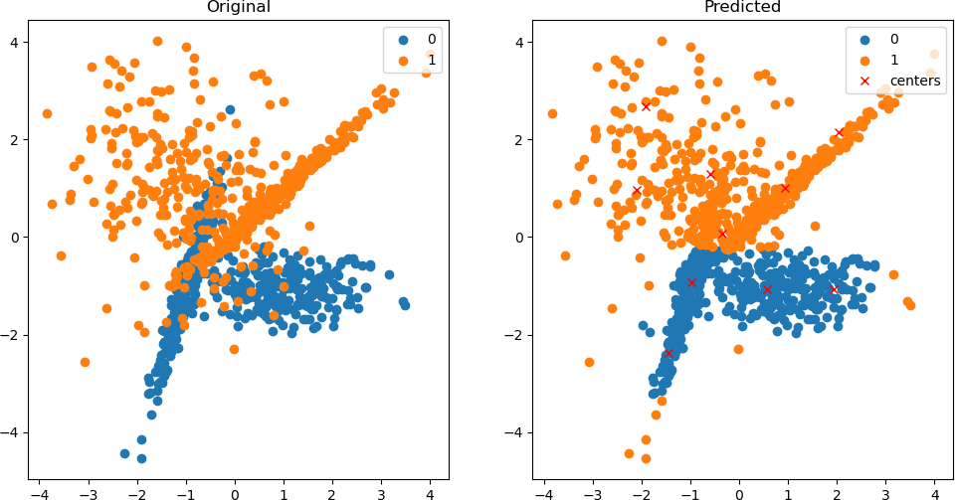

Result:
Thus a python program has been written and executed to implement Radial Basis function Neural Network model.

Ex. No. 3(b) RADIAL BASIS FUNCTION FOR XOR GATE
Date:

Aim:
To implement Radial Basis Function Neural Network for XOR gate using Python
Programming.

Program:
import numpy as np import pandas as pd
from sklearn.cluster import KMeans from scipy.spatial.distance import cdist

# Data
X = np.array([[0, 0], [0, 1], [1, 0], [1, 1]])
y = np.array([0, 1, 1, 0])
weight = np.array([-1, 1, 1, -1])

# Use X as centers (no clustering in this case) centers = np.copy(X)
print("Centers:\n", centers)

# Standard deviation std_dev = 1

# RBF activation function
def rbf_activation(X, centers, std_dev):
return np.around(np.exp(-cdist(X, centers, 'sqeuclidean') / (2 * std_dev**2)), decimals=1)

# Calculate RBF activations
rbf_x = rbf_activation(X, centers, std_dev)

# Prediction function def pred():
return np.dot(rbf_x, weight)

# Binary step function def step_fun(s):
return 1 if s > 0 else 0

# Calculate predictions pred_values = pred()
step_predictions = np.array([step_fun(val) for val in pred_values])

# Create DataFrame df = pd.DataFrame({
'Input': list(map(tuple, X)),
'RBF Activation': list(map(tuple, rbf_x)), 'Predicted Value': pred_values, 'Predicted Output': step_predictions
})

print("\nDataFrame:\n", df)

Input and Output:
Centers: [[0 0]
[0 1]
[1 0]
[1 1]]

DataFrame:

 | Input | RBF Activation | Predicted Value | Predicted Output
0 | (0, 0) | (1.0, 0.6, 0.6, 0.4) | -0.2 | 0
1 | (0, 1) | (0.6, 1.0, 0.4, 0.6) | 0.2 | 1
2 | (1, 0) | (0.6, 0.4, 1.0, 0.6) | 0.2 | 1
3 | (1, 1) | (0.4, 0.6, 0.6, 1.0) | -0.2 | 0

Result:
Thus a python program has been written and executed to implement Radial Basis function Neural Network model for an XOR gate.

Ex. No. 4(a) SUPPORT VECTOR MACHINE ON SOCIAL
MEDIA ADS DATASET
Date:
Aim:
To implement a Support Vector Machine on Social Media Ads dataset using Python
programming.

Support Vector Machine (SVM):
Support vector machines (SVMs) are powerful yet flexible supervised machine learning algorithms that are used both for classification and regression. But generally, they are used in classification problems. In the 1960s, SVMs were first introduced but later they got refined in 1990. SVMs have their unique way of implementation as compared to other machine learning algorithms. Lately, they are extremely popular because of their ability to handle multiple continuous and categorical variables.

Working of SVM
An SVM model is basically a representation of different classes in a hyperplane in multidimensional space. The hyperplane will be generated iteratively by SVM so that the error can be minimized. The goal of SVM is to divide the datasets into classes to find

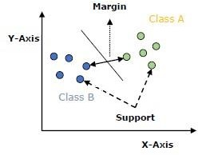
a maximum marginal hyperplane (MMH).
The following are important concepts in SVM:
- Support Vectors − Datapoints that are closest to the hyperplane are called support vectors. Separating lines will be defined with the help of these data points.
- Hyperplane − As we can see in the above diagram, it is a decision plane or space which is divided between a set of objects having different classes.
- Margin − It may be defined as the gap between two lines on the closet data points of different classes. It can be calculated as the perpendicular distance from the line to the support vectors. A large margin is considered as a good margin and a small margin is considered as a bad margin.

The main goal of SVM is to divide the datasets into classes to find a maximum marginal hyperplane (MMH) and it can be done in the following two steps −
- First, SVM will generate hyperplanes iteratively that segregate the classes in the best way.
- Then, it will choose the hyperplane that separates the classes correctly.

Program:
import numpy as np import pandas as pd
import matplotlib.pyplot as plt
from matplotlib.colors import ListedColormap from sklearn.preprocessing import StandardScaler
from sklearn.model_selection import train_test_split
from sklearn.metrics import confusion_matrix, accuracy_score from sklearn.svm import SVC
from sklearn import datasets, svm, metrics
df = pd.read_csv('datasets/Social_Network_Ads.csv') display(df.head())
X = df.iloc[:, [2, 3]].values y = df.iloc[:, 4].values
x_train, x_test, y_train, y_test = train_test_split(X, y, test_size=0.25, random_state=0) sc = StandardScaler()
x_train = sc.fit_transform(x_train) x_test = sc.transform(x_test)
classifier = SVC(kernel='rbf', random_state=0) classifier.fit(x_train, y_train)
y_pred = classifier.predict(x_test)
cm = confusion_matrix(y_pred, y_test) accuracy = accuracy_score(y_pred, y_test)

print("Confusion Matrix:\n", cm) print("Accuracy:", accuracy)
X1, X2 = np.meshgrid(
np.arange(start=x_test[:, 0].min()-1, stop=x_test[:, 0].max() + 1, step=0.01), np.arange(start=x_test[:, 1].min()-1, stop=x_test[:, 1].max() + 1, step=0.01)
)
plt.contourf( X1, X2,
classifier.predict(np.array([X1.ravel(), X2.ravel()]).T).reshape(X1.shape), alpha=0.75,
cmap = ListedColormap(('red', 'green'))
)
plt.xlim(X1.min(), X1.max())
plt.xlim(X2.min(), X2.max())
for i , j in enumerate(np.unique(y_test)):
plt.scatter(x_test[y_test==j, 0], x_test[y_test==j, 1], color=ListedColormap(('red', 'green'))(i), label=j)
plt.title('SVM(Test set)') plt.xlabel('Age') plt.xticks(())
plt.yticks(()) plt.ylabel('Estimated Salary') plt.legend()
plt.show()

Input and Output:

 | Users | Gender | Age | EstimatedSalary | Purchased
25 | 15631159 | Male | 47 | 20000 | 1
26 | 15792818 | Male | 49 | 28000 | 1
27 | 15633531 | Female | 47 | 30000 | 1
28 | 15744529 | Male | 29 | 43000 | 0
29 | 15669656 | Male | 31 | 18000 | 0

Confusion Matrix:
[[64 3]
[ 4 29]]
Accuracy: 0.93
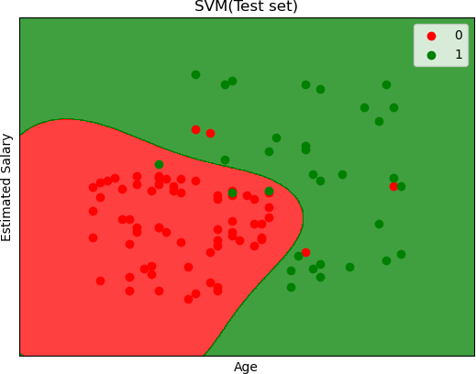

Result:
Thus a python program to implement Support Vector Machine on Social Media Ads Dataset has been written and executed.

Ex. No. 4(b) IMPLEMENTATION OF XOR GATE USING
SUPPORT VECTOR MACHINE

Date:

Aim:

To implement XOR gate with Support Vector Machine using Python programming.

Program:

import numpy as np
import matplotlib.pyplot as plt
from sklearn.metrics import classification_report from sklearn.svm import SVC
from sklearn.model_selection import train_test_split np.random.seed(0)
print("X:")
X = np.random.randn(200, 2) print(X[:5])
y_xor = np.logical_xor(X[:, 0] >0, X[:, 1]>0) def plot_gate(X, y, title):
plt.title(title)
plt.scatter(X[y==1, 0], X[y==1, 1], c='b', marker='x', label='1')
plt.scatter(X[y==0, 0], X[y==0, 1], c='r', marker='x', label='1') plt.show()
plot_gate(X, y_xor, "XOR")
(train_data, test_data, train_labels, test_labels) = train_test_split(X, y_xor, test_size=0.25, random_state=42)
model = SVC(kernel='poly', degree=2, coef0=1) model.fit(train_data, train_labels) print("Classification Report")
print(classification_report(test_labels, model.predict(test_data))),plt(x,model.predict(x),”Predicted”)

Input and Output:

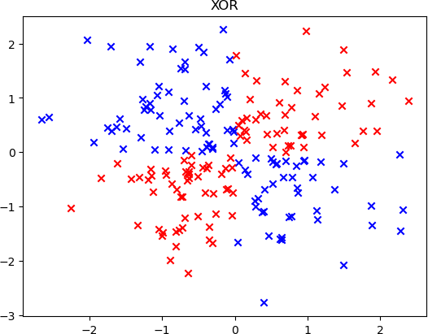
Classification Report:
precision recall f1-score support

False | 0.92 | 1.00 | 0.96 | 22
True | 1.00 | 0.93 | 0.96 | 28
accuracy |  |  | 0.96 | 50
macro avg | 0.96 | 0.96 | 0.96 | 50
weighted avg | 0.96 | 0.96 | 0.96 | 50
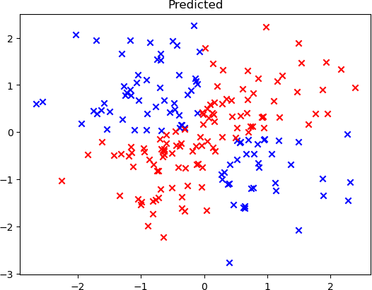

Result:
Thus a python program to implement XOR gate using Support Vector Machine has been written and executed.

Ex. No. 5 (a) SELF-ORGANIZING MAPS
Date:

Aim:
To implement a Self-Organizing Map using Python Programming.

Self-Organizing Maps:
It is a type of Artificial Neural Network which is also inspired by biological models of neural systems from the 1970s. It follows an unsupervised learning approach and trained its network through a competitive learning algorithm. SOM is used for clustering and mapping (or dimensionality reduction) techniques to map multidimensional data onto lower-dimensional which allows people to reduce complex problems for easy interpretation. SOM has two layers, one is the Input layer and the other one is the Output layer. The architecture of the Self Organizing Map with two clusters and n input features of any sample is given below:

Working Principle of SOM:
Let’s say an input data of size (m, n) where m is the number of training examples and n is the number of features in each example. First, it initializes the weights of size (n, C) where C is the number of clusters. Then iterating over the input data, for each training example, it updates the winning vector (weight vector with the shortest distance (e.g. Euclidean distance) from training example). Weight updation rule is given by:

wij = wij(old) + alpha(t) * (xik - wij(old))
where alpha is a learning rate at time t, j denotes the winning vector, i denotes the ith feature of training example and k denotes the kth training example from the input data. After training the SOM network, trained weights are used for clustering new examples. A new example falls in the cluster of winning vectors.

Algorithm:
- Weight initialization
- For 1 to N number of epochs
- Select a training example
- Compute the winning vector
- Update the winning vector
- Repeat steps 3, 4, 5 for all training examples.
- Clustering the test sample

Program:
import math class SOM :
# Function here computes the winning vector by Euclidean distance def winner( self, weights, sample ) :
D0 = 0
D1 = 0
for i in range(len(sample)):
D0 += (sample[i] - weights[0][i]) ** 2 D1 += (sample[i] - weights[1][i]) ** 2
If D0 < D1:
return 0
return 1 # Else Return 1
# Function here updates the winning vector def update(weights, sample, j, alpha ) :
for i in range(len(sample)):
weights[j][i] = weights[j][i] + alpha * (sample[i] - weights[j][i]) return weights
# Driver code
if name == " main ":
# Training Examples ( m, n )
T = [ [ 1, 1, 0, 0 ], [ 0, 0, 0, 1 ], [ 1, 0, 0, 0 ], [ 0, 0, 1, 1 ] ]
m, n = len( T ), len( T[0] )
# weight initialization ( n, C )
weights = [ [ 0.2, 0.6, 0.5, 0.9 ], [ 0.8, 0.4, 0.7, 0.3 ] ]
# training ob = SOM()
epochs = 3

alpha = 0.5
for i in range( epochs ) :
for j in range( m ) :
# training sample sample = T[j]
# Compute winner vector
J = ob.winner( weights, sample ) # Update winning vector
weights = ob.update( weights, sample, J, alpha ) # classify test sample
s = [ 1, 1, 0, 1 ]
J = ob.winner( weights, s )
print( "Test Sample s belongs to Cluster : ", J ) print( "Trained weights : ", weights )

Input and Output:
Test sample s belongs to: 1
Trained weights: [[0.003125, 0.009375, 0.6640625, 0.9984375], [0.996875, 0.334375,
0.0109375, 0.0046875]]

Result:
Thus a python program has been written and executed to implement Self Organizing
Map.

Ex. No. 5 (b) Learning Vector Quantization Date:

Aim:
To implement Learning Vector Quantization using Python Programming.

Program:

import math class LVQ:

# Function to compute the winning vector by Euclidean distance def winner(self, weights, sample):

distances = [sum(math.pow(sample[i] - weight[i], 2) for i in range(len(sample))) for weight in weights]

return distances.index(min(distances)) # Return index of the closest weight

# Function to update the winning vector

def update(self, weights, sample, J, alpha, actual):

if actual == J: # If the predicted class matches the actual class for i in range(len(weights[J])):
weights[J][i] += alpha * (sample[i] - weights[J][i]) # Move closer

else:
for i in range(len(weights[J])):
weights[J][i] -= alpha * (sample[i] - weights[J][i]) # Move away

# Driver code def main():
# Training Samples (m, n) with their class vector X = [[0, 0, 1, 1], [1, 0, 0, 0],
[0, 0, 0, 1], [0, 1, 1, 0],

[1, 1, 0, 0], [1, 1, 1, 0]]

Y = [0, 1, 0, 1, 1, 1] # Class labels m, n = len(X), len(X[0])

# Weight initialization (n, c) weights = []
weights.append(X.pop(0)) # First prototype weights.append(X.pop(0)) # Second prototype

# Samples used in weight initialization will not be used in training m -= 2
Y.pop(0)
Y.pop(0)

# Training ob = LVQ()
epochs = 3
alpha = 0.1
for _ in range(epochs): for j in range(m):
# Sample selection T = X[j]
# Compute winner
J = ob.winner(weights, T)

# Update weights ob.update(weights, T, J, alpha, Y[j])

# Classify new input sample T = [0, 0, 1, 0]
J = ob.winner(weights, T) print("Sample T belongs to class:", J) print("Trained weights:", weights)

if name == " main ": main()

Input and Output:
Sample T belongs to class: 0
Trained weights: [[0.0, -0.1791, 0.70299, 1.1791], [0.919, 0.5217031000000001,
0.31294900000000003, 0.0]]

Result:
Thus a python program has been written and executed to implement LVQ.

Ex. No. 6 FUZZY SET OPERATIONS
Date:
Aim:
To write a python program to find the algebraic sum, algebraic subtraction, algebraic product, bounded sum, bounded subtraction, and bounded product of two fuzzy sets.

Algorithm:
- Read the values of the two fuzzy sets.
- Perform the algebraic sum operation by, A + B= (a + b) – (a * b)
- Perform the algebraic subtraction operation by, A – B = (a + b`) where b`= 1- b
- Perform the algebraic product operation by, A * B = (a * b)
- Perform the bounded sum operation by, A ⊕B = min [1, (a + b)]
- Perform bounded subtraction operation by, A ⊝B= max [0, (a - b)]
- Perform bounded product operation by, A ⊙B = max [0, (a + b - 1)]
- Display the results

Program:

import numpy as np

# Input fuzzy sets
a = np.array(list(map(float, input("Enter fuzzy set A (space-separated): ").split())))
b = np.array(list(map(float, input("Enter fuzzy set B (space-separated): ").split())))

# Algebraic operations
asum = a + b - a * b # Algebraic sum
adiff = a + (1 - b) # Algebraic difference
aprod = a * b # Algebraic product
bsum = np.minimum(1, a + b) # Bounded sum
bdiff = np.maximum(0, a - b) # Bounded difference
bprod = np.maximum(0, a + b - 1) # Bounded product
# Display results
print("The algebraic sum:", asum)
print("The algebraic difference:", adiff)
print("The algebraic product:", aprod)
print("The bounded sum:", bsum)
print("The bounded difference:", bdiff)
print("The bounded product:", bprod)

Input and Output:
Enter fuzzy set A (space-separated): 1 0.5
Enter fuzzy set B (space-separated): 0.4 0.2
The algebraic sum: [1. 0.6]
The algebraic difference: [1.6 1.3]
The algebraic product: [0.4 0.1]
The bounded sum: [1. 0.7]
The bounded difference: [0.6 0.3]
The bounded product: [0.4 0. ]

Result:
Thus, a python program to perform simple fuzzy set operations has been executed and successfully verified.

Ex. No. 7 FUZZY SET PROPERTIES
Date:
Aim:
To write a program in python to verify the properties of fuzzy sets.
Algorithm:
To Verify the following Fuzzy Set Properties:
Commutative property

Associative property

Distributive property

Absorption property

Idempotency property

De Morgan’s law

Identity property
A ∪ B = B ∪ A A ∩ B = B ∩ A

(A ∪ B) ∪ C = A ∪ (B ∪ C) (A ∩ B) ∩ C = A ∩ (B ∩ C)

A ∪ (B ∩ C) = (A ∪ B) ∩ (A ∪ C)
A ∩ (B ∪ C) = (A ∩ B) ∪ (A ∩ C)

A ∪ (A ∩ C) = A A ∩ (A ∪ C) = A

A ∪ A = A A ∩ A = A

( A ∪ B )’ = A‘ ∩ B‘
( A ∩ B )’ = A’ ∪ B‘

A ∪ ϕ = A A ∩ X = A

Axiom of Excluded Middle

Axiom of Contradiction

Program:

import numpy as np

# Fuzzy sets
a = np.array([1.0, 0.4, 0.2])

b = np.array([0.2, 0.43, 0.44])

c = np.array([0.2, 0.93, 0.24])

e = np.array([1, 1, 1])

o = np.array([0, 0, 0])

print("A:", a)
print("B:", b)
print("C:", c)

# Union and Intersection
a_U_b = np.maximum(a,b)

a_N_b = np.minimum(a, b)

print("\nA U B:", a_U_b)

print("A N B:", a_N_b)

# Commutative Property

print("\nCommutative Property:")
print("A U B:", np.maximum(a, b))
print("B U A:", np.maximum(b, a))
print("A N B:", np.minimum(a, b))
print("B N A:", np.minimum(b, a))

A ∩ ϕ = ϕ

A ∪ X = X

print("\nAssociative Property:")
print("(A U B) U C:", np.maximum(np.maximum(a, b), c))
print("A U (B U C):", np.maximum(a, np.maximum(b, c)))
print("(A N B) N C:", np.minimum(np.minimum(a, b), c))
print("A N (B N C):", np.minimum(a, np.minimum(b, c)))

# Distributive Property
print("\nDistributive Property:")
print("A U (B N C):", np.maximum(a, np.minimum(b, c)))
print("(A U B) N (A U C):", np.minimum(np.maximum(a, b), np.maximum(a, c)))
print("A N (B U C):", np.minimum(a, np.maximum(b, c)))
print("(A N B) U (A N C):", np.maximum(np.minimum(a, b), np.minimum(a, c)))

# Absorption Property
print("\nAbsorption Property:")
print("A U (A N B):", np.maximum(a, np.minimum(a, b)))
print("A:", a)
print("A N (A U B):", np.minimum(a, np.maximum(a, b)))
print("A:", a)

print("\nIdempotent Law:")
print("A U A:", np.maximum(a, a))
print("A:", a)
print("A N A:", np.minimum(a, a))
print("A:", a)

# Involution Property
print("\nInvolution Property:")
print("(A')' :", 1 - (1 - a))
print("A:", a)

# De Morgan's Law
print("\nDe Morgan's Law:")
print("(A U B)' :", 1 - np.maximum(a, b))
print("A' N B':", np.minimum(1 - a, 1 - b))
print("(A N B)' :", 1 - np.minimum(a, b))
print("A' U B':", np.maximum(1 - a, 1 - b))

# Identity Property
print("\nIdentity Property:")
print("A U o:", np.maximum(a, o))
print("A:", a)
print("A N o:", np.minimum(a, o))
print("o:", o)
# Axiom of Excluded Middle
print("\nAxiom of Excluded Middle:")
print("A U A':", np.maximum(a, 1 - a))
print("E:", e)

# Axiom of Contradiction
print("\nAxiom of Contradiction:")
print("A N A':", np.minimum(a, 1 - a))
print("o:", o)

Input and Output:

A: [1. 0.4 0.2]
B: [0.2 0.43 0.44]
C: [0.2 0.93 0.24]

A U B: [1. 0.43 0.44]
A N B: [0.2 0.4 0.2]

Commutative Property:
A U B: [1. 0.43 0.44]
B U A: [1. 0.43 0.44]
A N B: [0.2 0.4 0.2]
B N A: [0.2 0.4 0.2]

Associative Property:
(A U B) U C: [1. 0.93 0.44]
A U (B U C): [1. 0.93 0.44]
(A N B) N C: [0.2 0.4 0.2]
A N (B N C): [0.2 0.4 0.2]

Distributive Property:
A U (B N C): [1. 0.43 0.24]
(A U B) N (A U C): [1. 0.43 0.24]
A N (B U C): [0.2 0.4 0.2]
(A N B) U (A N C): [0.2 0.4 0.2]

Absorption Property:
A U (A N B): [1. 0.4 0.2]
A: [1. 0.4 0.2]
A N (A U B): [1. 0.4 0.2]
A: [1. 0.4 0.2]

Idonmpotent Law:
A U A: [1. 0.4 0.2]
A: [1. 0.4 0.2]
A N A: [1. 0.4 0.2]
A: [1. 0.4 0.2]

Involution Property:
(A')' : [1. 0.4 0.2]
A: [1. 0.4 0.2]

De Morgan's Law:
(A U B)' : [0. 0.57 0.56]
A' N B': [0. 0.57 0.56]
(A N B)' : [0.8 0.6 0.8]
A' U B': [0.8 0.6 0.8]

Identity Property:
A U o: [1. 0.4 0.2]
A: [1. 0.4 0.2]
A N o: [0. 0. 0.]
o: [0 0 0]

Axiom of Excluded Middle:
A U A': [1. 0.6 0.8]
E: [1 1 1]

Axiom of Contradiction:
A N A': [0. 0.4 0.2]
o: [0 0 0]

Result:
Thus, a python program to verify fuzzy set properties has been executed and successfully verified.

Ex. No. 8 FUZZY MEMBERSHIP FUNCTIONS
Date:
Aim:
To write a program in python to plot triangular, trapezoidal and bell shaped membership functions.

Algorithm:
- Set the limits of x-axis.
- Calculate y using trimf() function with three parameters for triangular membership function.
- Calculate y using trapmf() function with four parameters for trapezoidal membership function.
- Calculate y using gbellmf() function with three parameters for bell shaped membership function.
- Plot x and y values.

Program:

import numpy as np
import skfuzzy as fuzz
import matplotlib.pyplot as plt

x = np.arange(0, 11, 1.0)
x1 = np.arange(0, 10, 0.1)
y1 = fuzz.trimf(x, [1, 3, 5])
y2 = fuzz.trapmf(x, [1, 3, 5, 7])
y3 = fuzz.gbellmf(x1, 2, 4, 5)

fig, axs = plt.subplots(3, 1, figsize=(6, 8))
axs[0].plot(x, y1)
axs[0].set_title("Triangular Membership Function")

axs[1].plot(x, y2)
axs[1].set_title("Trapezoidal Membership Function")

axs[2].plot(x1, y3)
axs[2].set_title("Bell-shaped Membership Function")
plt.tight_layout()
plt.show()

Output:
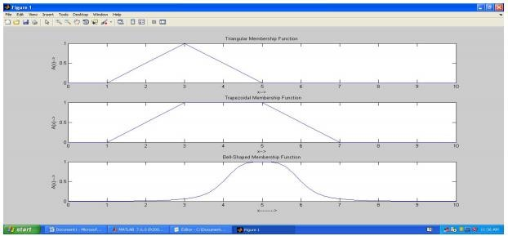

Result:
Thus, the python program for plotting membership functions has been executed successfully and the output is verified.

Ex. No. 9 FUZZY INFERENCE SYSTEM
Date:
Aim:
To implement a Fuzzy Inference System (FIS) using MATLAB.
Inputs: Temperature and Cloud Cover
Temperature: {Freeze, Cool, Warm and Hot}
Cloud Cover: {Sunny, Partly Cloud, and Overcast}
Output: Speed
Speed : {Fast and Slow}

Rules:
- If cloud cover is Sunny and temperature is warm, then drive Fast Sunny (Cover) and Warm (Temp) -> Fast (Speed)
- If the cloud cover is cloudy and the temperature is cool, then drive Slow Cloudy (Cover) and Cool (Temp) -> Slow (Speed)

Procedure:
  - Go to the command window in Matlab and type fuzzy.
  - Now, a new Fuzzy Logic Designer window will be opened.
  - Input / Output Variable
    - Go to Edit Window and click Add variable.
    - As per our requirements create two input variables, Temperature and Cloud Cover.
    - Create one output variable, Speed.
  - Temperature:
    - Double click the Temperature input variable in the Fuzzy Logic Designer window.
    - A new window will be opened and remove all the Membership Functions.
    - Now, Go to Edit, Click Add MFs and select the 4 Parameters for Temperature Class.
    - Change the following fields as mentioned data in the given below table.

Inputs : Temperature ◻ Freezing, Cool, Warm and Hot
MF1: | MF2: | MF3: | MF4:
Range : [0 110] | Range : [0 110] | Range : [0 110] | Range : [0 110]
Name : Freezing | Name : Cool | Name : Warm | Name : Hot
Type :trapmf | Type :trimf | Type :trimf | Type :trapmf
Parameter [0 0 30 50] | Parameter [30 50 70] | Parameter [50 70 90] | Parameter [70 90 110 110]

  - Similarly, add the datas to the Cloud Cover variables and Speed variables.
  - Cloud Cover:

Inputs : Cloud Cover ◻ Sunny, Partly Cloud and Overcast
MF1: | MF2: | MF3:
Range : [0 100] | Range : [0 100] | Range : [0 100]
Name : Sunny | Name : Partly Cloud | Name : Overcast
Type :trapmf | Type :trimf | Type :trapmf
Parameter [0 0 20 40] | Parameter [20 50 80] | Parameter [60 80 100]

  - Speed:

Output : Speed ◻ Slow and Fast
MF1:  Range : [0 100] Name : Slow Type :trapmf  Parameter [0 0 25 75] | MF2:  Range : [0 100] Name : Fast Type :trapmf  Parameter [25 75 100 100]

  - Goto Rules: Edit ◻ Rules
  - Add the Rules
Rule-1: Sunny (Cover) and Warm (Temp) -> Fast (Speed) Rule-2: Cloudy (Cover) and Cool (Temp) -> Slow (Speed)
  - Go to view ◻ Rules
  - Exit.

Input and Output:
Membership functions for Temperature variable

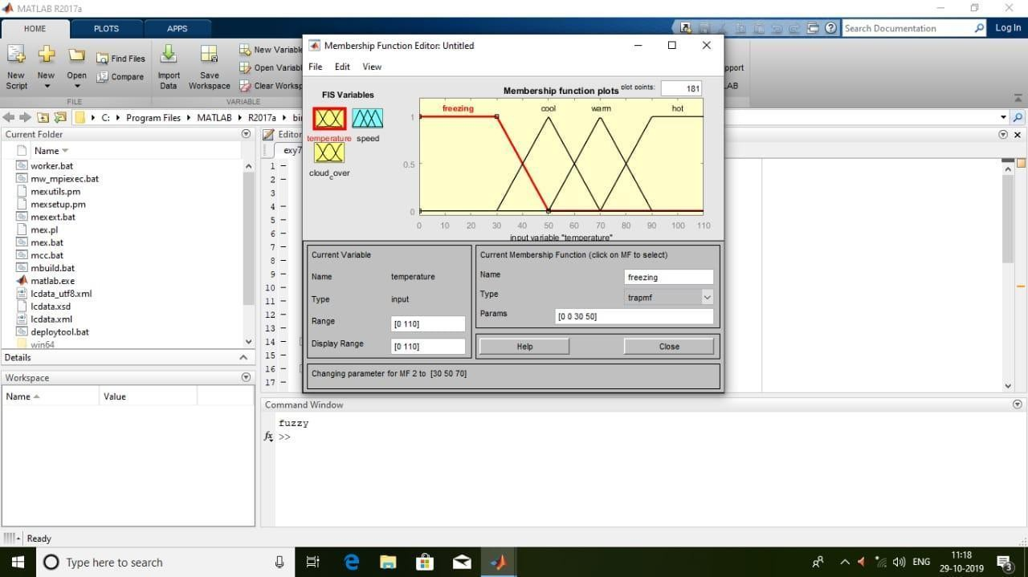
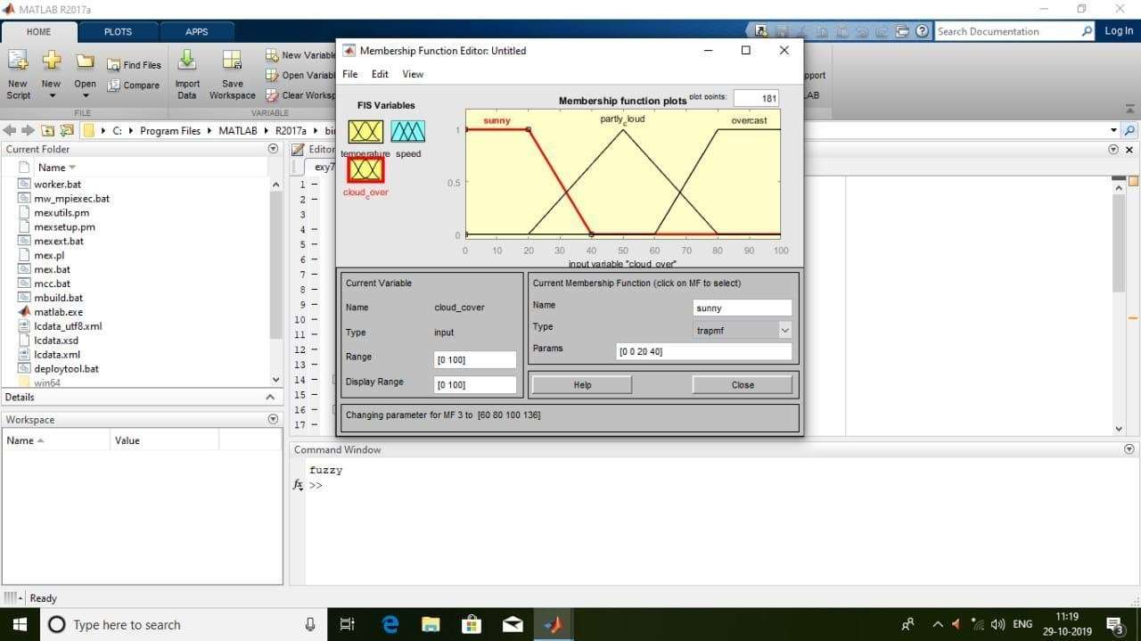

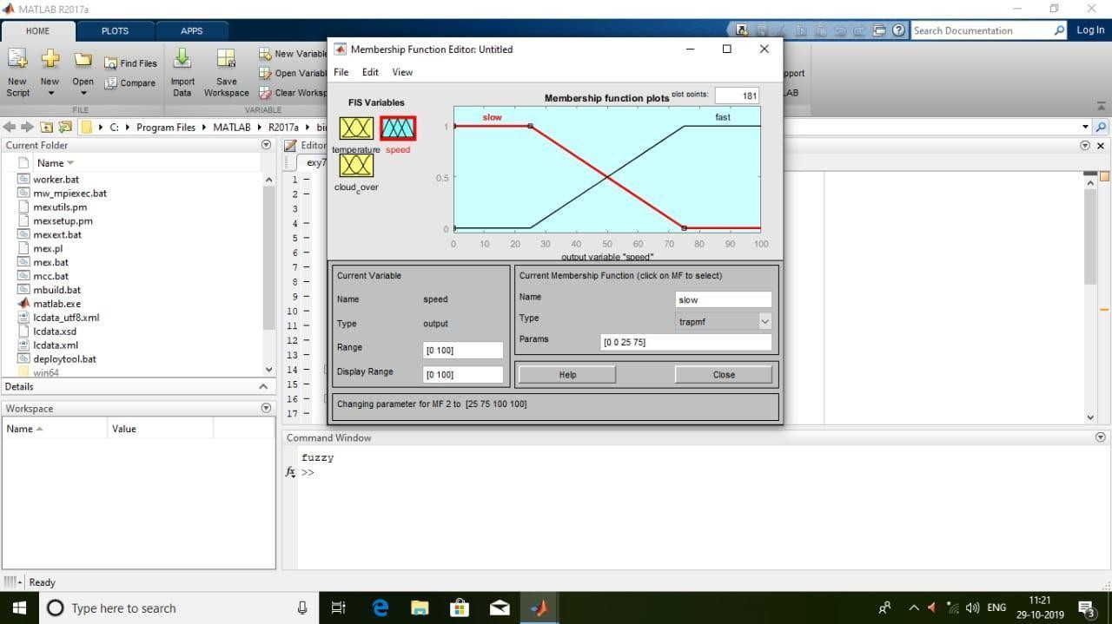

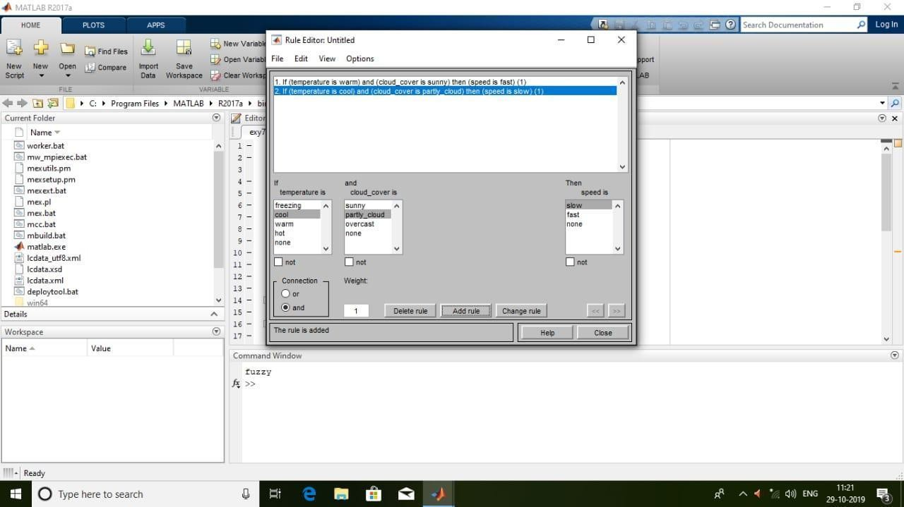
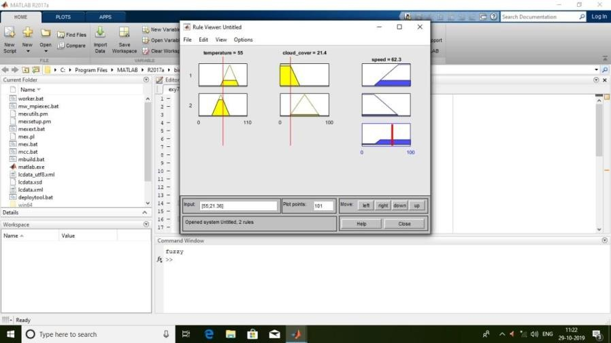

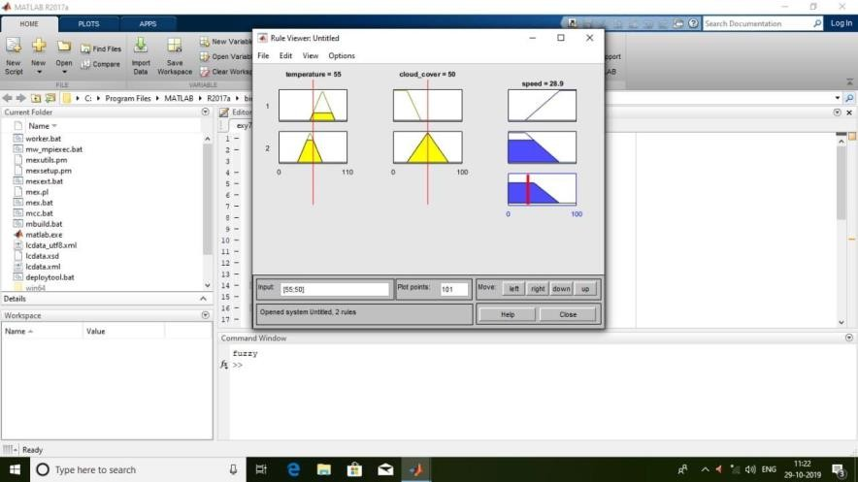

Result:
Thus a Fuzzy Inference System is successfully executed using MATLAB.

Ex. No. 10 Defuzzification Methods Date:

Aim:
To write a program in Python to implement defuzzification methods using fuzzy
toolbox.

Algorithm:
- Import numpy, matplotlib and skfuzzy packages.
- Trapezoidal membership function on range [0, 1] using trapmf function with four parameters.
- Defuzzify trapezoidal membership function by using fuzzy toolbox functions centroid, bisector, mom, Som and lom.
- Plot the defuzzified values using matplotlib.

Program:
import numpy as np

import matplotlib.pyplot as plt import skfuzzy as fuzz
# Generate trapezoidal membership function on range [0, 1] x = np.arange(1, 5.05, 0.1)
mfx = fuzz.trapmf(x, [2, 2.5, 3, 4.5])

# Defuzzify this membership function five ways defuzz_centroid = fuzz.defuzz(x, mfx, 'centroid') defuzz_bisector = fuzz.defuzz(x, mfx, 'bisector') deuzz_mom = fuzz.defuzz(x, mfx, 'mom') defuzz_som = fuzz.defuzz(x, mfx, 'som') defuzz_lom = fuzz.defuzz(x, mfx, 'lom')

# Collect info for vertical lines

labels = ['centroid', 'bisector', 'mean of maximum', 'min of maximum', 'max of maximum'] xvals = [defuzz_centroid, defuzz_bisector, defuzz_mom, defuzz_som, defuzz_lom]
colors = ['r', 'b', 'g', 'c', 'm']

ymax = [fuzz.interp_membership(x, mfx, i) for i in xvals]

# Display and compare defuzzification results against membership function plt.figure(figsize=(8, 5))
plt.plot(x, mfx, 'k')

for xv, y, label, color in zip(xvals, ymax, labels, colors): plt.vlines(xv, 0, y, label=label, color=color)
plt.ylabel('Fuzzy membership') plt.xlabel('Universe variable (arb)') plt.ylim(-0.1, 1.1) plt.legend(loc=2)
plt.show()

Output:

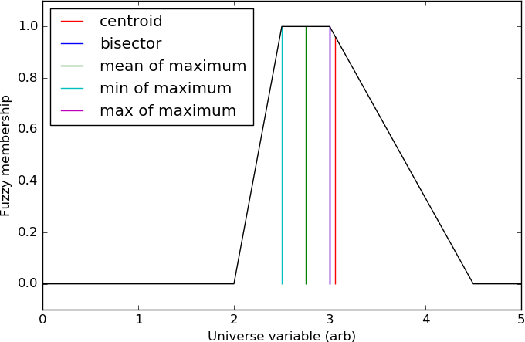

Result:
Thus, the Python program for implementing defuzzification methods has been executed successfully and the output is verified.

Ex. No. 11 THE TIPPING PROBLEM
Date:
Aim:
To develop a fuzzy controller for the Tipping problem using Python programming.

The Tipping Problem:
The 'tipping problem' is commonly used to illustrate the power of fuzzy logic principles to generate complex behavior from a compact, intuitive set of expert rules.

A fuzzy control system is created to model how you might choose to tip at a restaurant. When tipping, the service and food quality are considered and rated between 0 and 10. A tip of between 0 and 25% is suggested.

Problem Formulation:

Inputs

service
Universe (ie, crisp value range): How good was the service of the wait staff, on a scale of 0 to 10?
Fuzzy set (ie, fuzzy value range): poor, acceptable, amazing

food quality
Universe: How tasty was the food, on a scale of 0 to 10? Fuzzy set: bad, decent, great
Consequents (Outputs)

tip
Universe: How much should we tip, on a scale of 0% to 25% Fuzzy set: low, medium, high

Rules
IF the service was good or the food quality was good,
THEN the tip will be high.
IF the service was average, THEN the tip will be medium. IF the service was poor and the food quality was poor
THEN the tip will be low.
Usage
If I tell this controller that I rated:
the service as 9.8, and the quality as 6.5,
it would recommend I leave: a 20.2% tip.

Creating the Tipping Controller Using the skfuzzy control API

import numpy as np import skfuzzy as fuzz

from skfuzzy import control as ctrl

# New Antecedent/Consequent objects hold universe variables and membership # functions
quality = ctrl.Antecedent(np.arange(0, 11, 1), 'quality')
service = ctrl.Antecedent(np.arange(0, 11, 1), 'service')
tip = ctrl.Consequent(np.arange(0, 26, 1), 'tip')

# Auto-membership function population is possible with .automf(3, 5, or 7) quality.automf(3)
service.automf(3)

# Custom membership functions can be built interactively with a familiar, # Pythonic API
tip['low'] = fuzz.trimf(tip.universe, [0, 0, 13])
tip['medium'] = fuzz.trimf(tip.universe, [0, 13, 25])
tip['high'] = fuzz.trimf(tip.universe, [13, 25, 25])

# You can see how these look with .view() quality['average'].view()
service.view() tip.view()

rule1 = ctrl.Rule(quality['poor'] | service['poor'], tip['low']) rule2 = ctrl.Rule(service['average'], tip['medium'])
rule3 = ctrl.Rule(service['good'] | quality['good'], tip['high']) rule1.view()
tipping_ctrl=ctrl.ControlSystem([rule1,rule2,rule3])

tipping = ctrl.ControlSystemSimulation(tipping_ctrl)
# Pass inputs to the ControlSystem using Antecedent labels with Pythonic API # Note: if you like passing many inputs all at once, use .inputs(dict_of_data) tipping.input['quality'] = 6.5
tipping.input['service'] = 9.8

# Crunch the numbers tipping.compute() print(tipping.output['tip']) tip.view(sim=tipping)

Output:
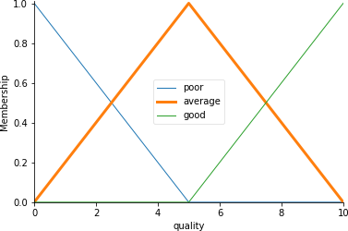

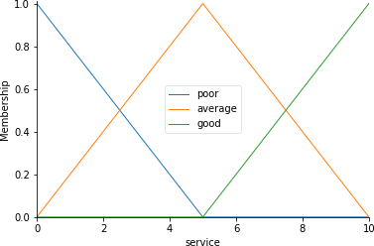

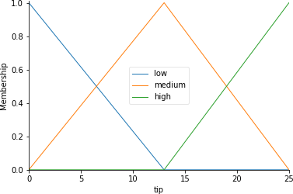
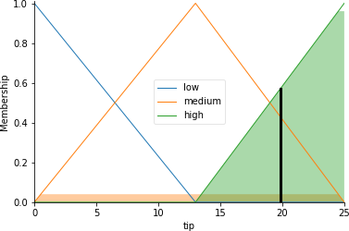

The resulting suggested tip is 20.24%.

Result:
Thus, the Python program for developing a fuzzy controller for the Tipping problem has been executed successfully and the output is verified.

